Biosecurity Managers can use this worksheet to test their knowledge after reviewing all the resources in the Biosecurity Manager Guide

Biosecurity Manager Guide Interactive Worksheet

Section 1: Know the Site

- The three most important things to consider when “knowing the site” are its: ____________________, ____________________, ____________________.

- Which of the following best describes biosecurity?

- The nutritional strategies used to increase growth and production on an operation.
- The management practices implemented at different levels of disease prevention, to keep diseases off the operation.
- The economic planning used to reduce costs associated with animal care.
- The environmental practices focused on waste management and sustainability.

- Complete the following stair-step approach for enhancing biosecurity.
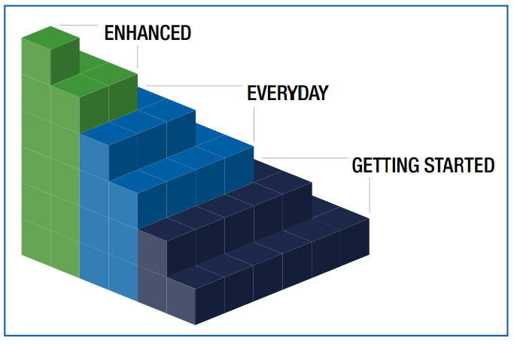
Section 2: Develop, Update, or Revise an Enhanced Biosecurity Plan

- ______________ refers to practices that align with the SFS species-specific plan and are ready to put into place in the event of a FAD Outbreak.

- Enhanced biosecurity plans should be reviewed at least ______________.

- True or False: If an operation has multiple locations, only one plan is needed.

- What is the purpose of the Line of Separation (LOS)?____________________________________________________

- Cleaning and ____________________ removes and kills pathogens.

Section 3: Communicate Biosecurity Practices to Everyone Who Enters the Operation

- Training for site-dedicated personnel should be repeated:
  - Once every five years
  - Only during outbreaks
  - At least yearly
  - Only when new employees arrive

- True or False: All biosecurity training must be in languages employees understand.

- List two groups of non-farm personnel who must receive biosecurity training._________________________________________________

Section 4: Train Staff on How to Implement Enhanced Biosecurity Practices in the Event of a FAD Outbreak

- Training staff to implement enhanced biosecurity is essential in keeping _____________________off operations and preventing further spread on affected operations during an outbreak.

- Which resource offers training videos and documentation tools?
  - State Fair guide
  - Secure Food Supply Plan websites
  - Local Extension newsletter
  - Weather service

- True or False: Documenting training is important.

- Why is training important during an outbreak?

Section 5: Take Corrective Actions When Biosecurity Practices Are Not Followed

- Managers should create a work culture that __________ employees for correct actions.

- Which is not a compliance method?
- Daily monitoring
- Coaching and remedial activities
- Repeating training
- Ignoring minor violations

- True or False: Corrective actions must align with personnel management strategies.

